Final Project Report

**for Development of Web Applications**



|  |  |
| --- | --- |
| Omar Einea | U14111378 |
| Anas Einea | U14111377 |
| Basel Shublaq | U14112207 |
| Abdulahi Osoble | U14110183 |

Supervised by: Dr. Djedjiga Mouheb

College of Sciences

University of Sharjah

December 2017

**Idea:**

The idea of our website is an e-commerce company “Pensell” – which is the combination of two words; “Pen”, “Sell” – reflecting of what the company does, that is selling office supplies. There are four main categories; Office Furniture, Printers, Notebooks, and Bags. Each category contains 5 items, so in total we have 20 products.

**Implementation:**

***First***, we created the database “WebApps”, which contains the table “Products”. The table contains 6 attributes. They are: descriptionS, descriptionL, image, name, price, and tag. We then collected the data to be populated into the database. The data was collected from various sources, including but not limited to, Amazon.com and Souq.com.

“descriptionS” contains a small description for the item, while “descriptionL” is the full description of the item.

“image” contains the path of the image used in display of each product, and is the primary key because no two products have the same image. All images are 500x333px.

“name” is the name of the item.

“price” is the cost of the item.

“tag” is used for grouping the items into separate categories, as mentioned before.

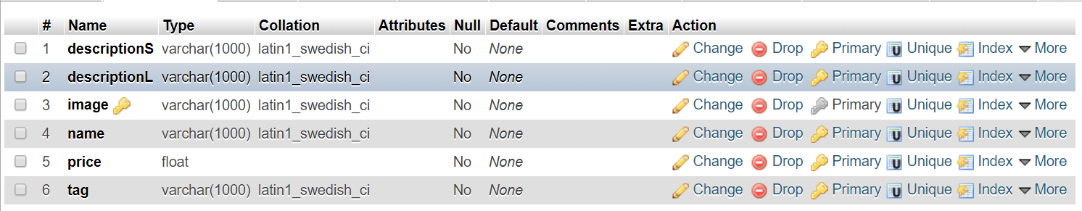Next step, we populated the table with all the data we collected previously, using WampServer’s localhost. After being done with that, we exported the table into a “.sql” file.

Figure 1: Structure of the Products Table

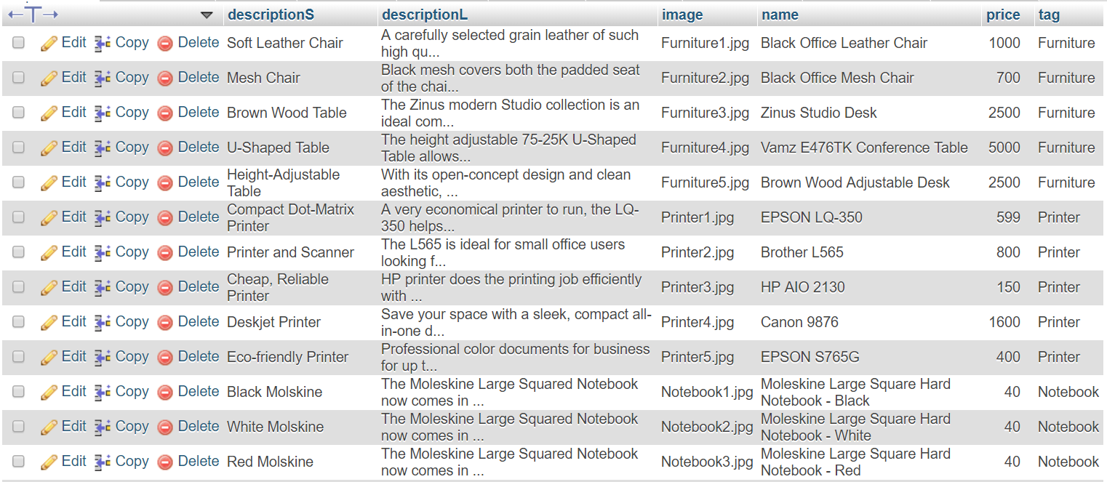

Figure 2: Snapshot of part of the Products Table

***Second***, we drew the logo.

***Third***, we divided the work between us and started coding. We also used GitHub to manage and control the code. Our website is basically implementing most concepts we learned throughout the course. It has a shopping cart system, a sign-up system, a sign-in and sign-out system, sessions system, and a user authentication system.

We used Materialize, which is a modern responsive front-end framework. It has CSS as well as JavaScript components. It provides a much easier experience for optimizing web pages for different screen and window sizes.

**Resources:**

* **GitHub** [www.github.com](http://www.github.com)
* **Materialize CSS** [www.materializecss.com](http://www.materializecss.com)
* **Brackets** [www.brackets.io](http://www.brackets.io)
* **WampServer** [www.wampserver.com](http://www.wampserver.com)
* **Stack Overflow** [www.stackoverflow.com](http://www.stackoverflow.com)
* **W3Schools** [www.w3schools.com](http://www.w3schools.com)
* **Amazon** [www.amazon.com](http://www.amazon.com)
* **Souq** [www.souq.com](http://www.souq.com)
* **WhatsApp** [www.whatsapp.com](http://www.whatsapp.com)
* **Inkscape** [www.inkscape.org](http://www.inkscape.org)
* **Google Chrome** [www.google.com/chrome/browser](http://www.google.com/chrome/browser)
* **Microsoft Word** [www.office.com](http://www.office.com)
* **Microsoft Windows** [www.microsoft.com/windows](http://www.microsoft.com/windows)
* **HP Notebook** [www.hp.com](http://www.hp.com)
* **MacBook** [www.apple.com](http://www.apple.com)
* **Monster Notebook** [www.monsternotebook.com.tr](http://www.monsternotebook.com.tr)
* **Pensell Version 1** <https://anaseinea.github.io/IT_E-Commerce>